QUESTION 6 REPORT ASTA 607 22424366

This is a report on a comprehensive descriptive and comparative analysis of the crabs dataset from the MASS package. The data reflects five morphological measurements (Frontal Lobe, Rear Width, Carapace Length, Carapace Width, and Body Depth) taken from 200 crabs of the species Leptograpsus variegatus collected at Fremantle, Western Australia. The primary aim of this study is to evaluate how species (Blue or Orange) and sex (Male or Female) influence physical dimensions and to determine the strength of the relationships between these different morphological traits.

ANALYSIS OF DATA STRUCTURE AND COMPOSITION
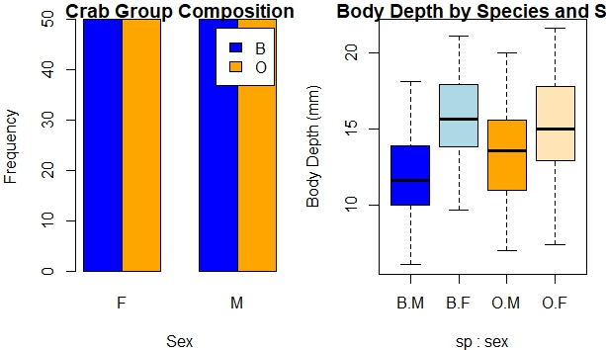
The dataset comprises 200 observations across 8 variables. Preliminary inspection confirms that the experimental design is perfectly balanced, consisting of exactly 50 specimens for each of the four subgroups: Blue Female (B.F), Blue Male (B.M), Orange Female (O.F), and Orange Male (O.M).

This balance is statistically significant as it ensures that group means and variances are estimated with equal precision, preventing any single group from disproportionately influencing the global analysis.
BODY DEPTH (BD) AND CARAPACE LENGTH (CL) DISTRIBUTION
Analysis of Body Depth (BD) through side-by-side boxplots indicates clear differentiation between groups.
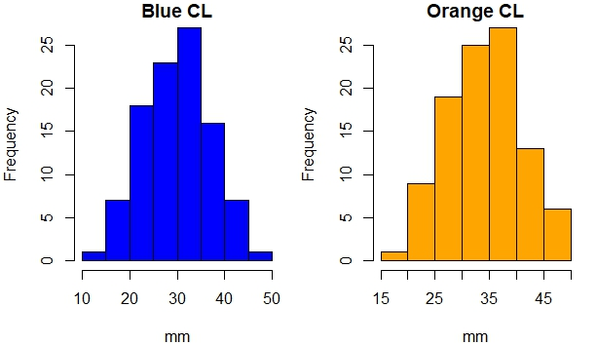
The Orange species generally exhibits a greater body depth than the Blue species. Within species, males typically possess a larger median body depth than females. The distributions for Carapace Length (CL) were found to be unimodal and approximately symmetric for both species, suggesting a consistent and representative sampling of the population's growth stages.

COMPARATIVE MORPHOLOGICAL MEANS
The following table provides the calculated mean values for each morphological measurement stratified by species and sex:
Mean Morphological Measurements by Group (mm)
sp sex FL RW CL CW BD
1 B F 13.270 12.138 28.102 32.624 11.816
2 O F 17.594 14.836 34.618 39.036 15.632
3 B M 14.842 11.718 32.014 36.810 13.350
4 O M 16.626 12.262 33.688 37.188 15.324

These results are visually summarized in the grouped bar chart below, which highlights the variations across the five dimensions:

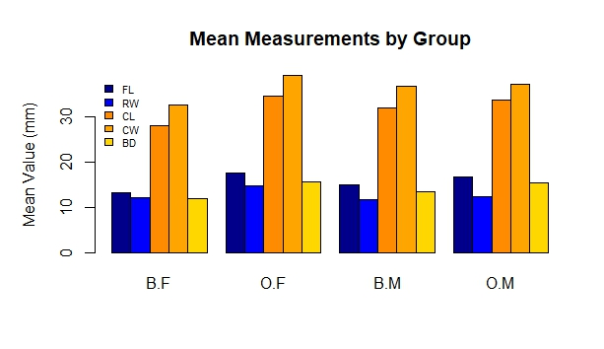

Numerical evidence indicates that Carapace Width (CW) and Carapace Length (CL) are the measurements that best distinguish the species, with Orange crabs consistently scoring higher than Blue crabs. Conversely, the Frontal Lobe (FL) shows the least variation between sexes, suggesting it is a stable trait across the species regardless of gender.

RELATIONSHIPS AND GROWTH PATTERNS
A scatterplot matrix was utilized to evaluate the nature of the relationships among variables.
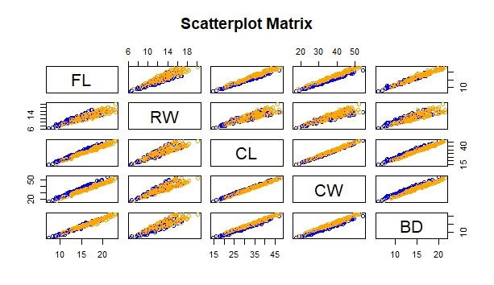
The results indicate an extremely strong, positive linear relationship between all five measurements. This suggests high multicollinearity, where the growth of one body part (e.g., Carapace Width) is directly proportional to the growth of others (e.g., Body Depth). This isometric growth pattern is consistent across both species and sexes.

CONCLUSION
The morphological analysis of the Leptograpsus crab dataset reveals that species is the most significant factor determining physical size, with Orange crabs being consistently larger than their Blue counterparts. While sexual dimorphism is evident, particularly in Body Depth, the differences are less pronounced than those between species. The near-perfect linear correlations observed suggest that the biological development of these traits is highly integrated. Future research should employ Principal Component Analysis (PCA) to isolate shape-specific variations that may exist independently of overall size increases. That is, PCA may be used to further explore shape variations that are not immediately obvious from linear size measurements.

